Total Marks: | 7.5
Obtained Marks:

Object Oriented Programming
LAB

Project Proposal

Inventory Management System
(Used by businesses to manage stock)

Submitted To:Mr. Muhammad Hassan Mujtaba

Names | Reg#
Ayad Ullah Baig | 25108293
Ali Azhan Khan | 25108290
Saad Ali Khan | 25108329

Table of Contents
1. Executive Summary ....................................................................................
. A high-level overview of the IIMS and the necessity of automated tracking.
2. Project Objectives .......................................................................................
Primary goals including record-keeping accuracy and secure role-based access.
3. Functional Features ....................................................................................
Core capabilities such as product registration, sales recording, and data storage.
4. Core OOP Concepts Applied .......................................................................
Technical implementation of Encapsulation, Abstraction, Inheritance, and Polymorphism.
5. System Architecture & Features .............................................................…
Detailed look at the Inventory Control engine, Sales Engine, and persistent file handling.
6. Development Roadmap ..............................................................................
A four-step lifecycle covering planning, class design, modular building, and testing.
7. System Design & Class Structure .............................................................. Architectural decisions regarding dynamic storage (Vectors) and menu-driven interfaces.
8. Flowchart & Logic Explanation ..............................................................…
Visual representation of the dual-access login and administrative workflows.
9. Individual Contribution & Work Distribution .......................................…
Breakdown of class implementation, data handling, and module validation.
10. Proposed & Future Enhancements .......................................................…
Scaling the project with Low Stock Alerts, GUI integration, and Cloud connectivity.
11. References & Conclusion .......................................................................... Academic citations and final thoughts on the system's scalability.

1. Executive Summary
Keeping track of inventory by hand is slow, error-prone, and honestly just a headache for any business. The Intelligent Inventory Management System (IIMS) is a C++ application built to take care of that — handling product tracking, stock monitoring, and sales recording automatically. The whole system is built around Object-Oriented Programming, which keeps the code clean, organized, and easy to expand later.

2. Objectives of the Project
The main goals of the Inventory Management System are:
 . Automate inventory tracking for faster and accurate record-keeping.
 . Monitor stock levels to prevent overstocking or shortages.
 . Record sales transactions and calculate totals automatically.
. Provide role-based access for secure data modification.
 . Enhance decision-making through organized data management.

3. Functional Features
1. Add New Products – Register product details (ID, name, price, quantity).
2.Update Inventory – Modify stock quantities.
3. Search Products – Retrieve product information using ID or name.
4. Record Sales – Deduct sold quantities and calculate total price.
5.View Inventory and Sales – Display current stock and sales history.
6.Role-Based Access Control – Admin/User login for secure operations.
7.Persistent Data Storage – Store data in files for long-term use.

4. Core OOP Concepts Applied
Concept | How It's Used in IIMS
Encapsulation | Product details like price, ID, and quantity are kept private inside the Product class. You can only access or change them through proper getter and setter functions.
Abstraction | From the user's side, it's just a simple menu. All the behind-the-scenes logic — stock deductions, total calculations — stays hidden inside the class methods.
Inheritance | A base User class holds shared attributes like username and password. Admin and Customer are derived from it, each with their own specific permissions.
Polymorphism | The << operator is overloaded for clean product output, and virtual functions allow the system to handle different product types like perishable and non-perishable items.

5. System Architecture & Features
What the system can do:
- Inventory Control: Add, update, and search products using unique IDs.
- Sales Engine: Process a sale, calculate the total, and automatically reduce stock.
- Reporting: View current stock levels and past sales history at any point.
How it works under the hood:
- Users log in as either Admin or a standard User.
- Products are stored using STL Vectors for flexible, dynamic memory management.
- All data is saved to .txt or .dat files so it persists between sessions.
6. Development Roadmap
Step 1 — Planning: Figure out what data needs to be stored (ID, name, price) and define what each user role can and can't do.
Step 2 — Class Design: Build the Product and InventoryManager classes. The inventory uses a composition relationship — it contains a collection of products.
Step 3 — Building It: Write the actual C++ code in a modular way and plug in File I/O for saving data.
Step 4 — Testing:
- Check that individual functions like searchProduct() work correctly.
- Test edge cases — like what happens when something goes out of stock.

7.Flow Chart
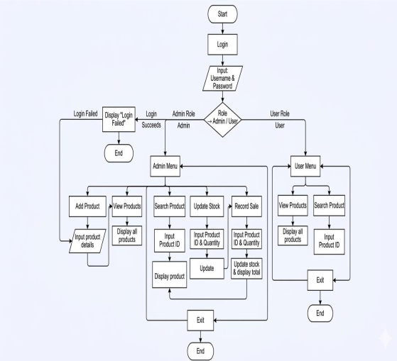
8.Explanation Of Flowchart
The flowchart illustrates the dual-access logic of the Inventory Management System, where a secure login authenticates users into Admin or Standard roles. Upon successful login, the Admin gains full system privileges, including adding products, updating stock, and recording sales, whereas the Standard User is limited to viewing and searching product data. Each specific action leads to targeted input prompts—such as Product ID or Quantity—ensuring that data modification is guided and structured. This architecture reinforces the project's core OOP principle of Encapsulation by restricting critical inventory modifications to authorized administrative paths only. The cycle concludes with a formal exit point for both user types, maintaining a clean and professional program termination.

9.Proposed Enhancements
- Low Stock Alerts: Automatically flag any item that drops below a set threshold (e.g., under 5 units).
- GUI Upgrade: Eventually move from a console interface to a proper graphical one using Qt or SFML.
- Sales Trends: Add simple logic to identify which products are moving the fastest.

10. Contribution / Individual Work
 . Design and implementation of all class structures and functions.
. Development of menu-driven interface for user interaction.
. Implementation of data handling using vectors and optional file storage.
. Testing and validation of all modules to ensure functionality.

11. Future Enhancements
 1.Graphical User Interface (GUI) – Enhance usability.
 2.Low Stock Alerts – Automatic notifications for low inventory.
 3.Supplier Management – Track supplier details and automate reordering.
 4.Detailed Reporting – Generate analytical reports for sales and inventory.
 5.Database Integration – Use SQL or NoSQL databases for large-scale applications.
 6.Cloud Connectivity – Enable multi-location inventory management.

12.System Design
1. Design class structures for Product and Inventory to encapsulate data.
2. Decide on dynamic data storage using vectors.
3. Create a menu-driven interface for user interaction.
4. Plan optional enhancements such as file handling and login system.

13. References
1. Stroustrup, B. The C++ Programming Language, 4th Edition, Addison-Wesley, 2013.
2. Lafore, R. Object-Oriented Programming in C++, 4th Edition, Sams Publishing, 2002.
3. Schildt, H. C++: The Complete Reference, 5th Edition, McGraw-Hill, 2003.
4. Online resources: TutorialsPoint C++ OOP Concepts
https://www.tutorialspoint.com/cplusplus/cpp_object_oriented.html

14. Conclusion
IIMS isn't just a glorified spreadsheet — it's a practical demonstration of how C++ and OOP principles can solve a real business problem. The focus on clean structure, secure access, and persistent data makes it a solid base that could realistically be scaled up into something much larger.

